Alan Li

EE 371

January 15th, 2022

Lab 1 Report

## Section 1: Procedure

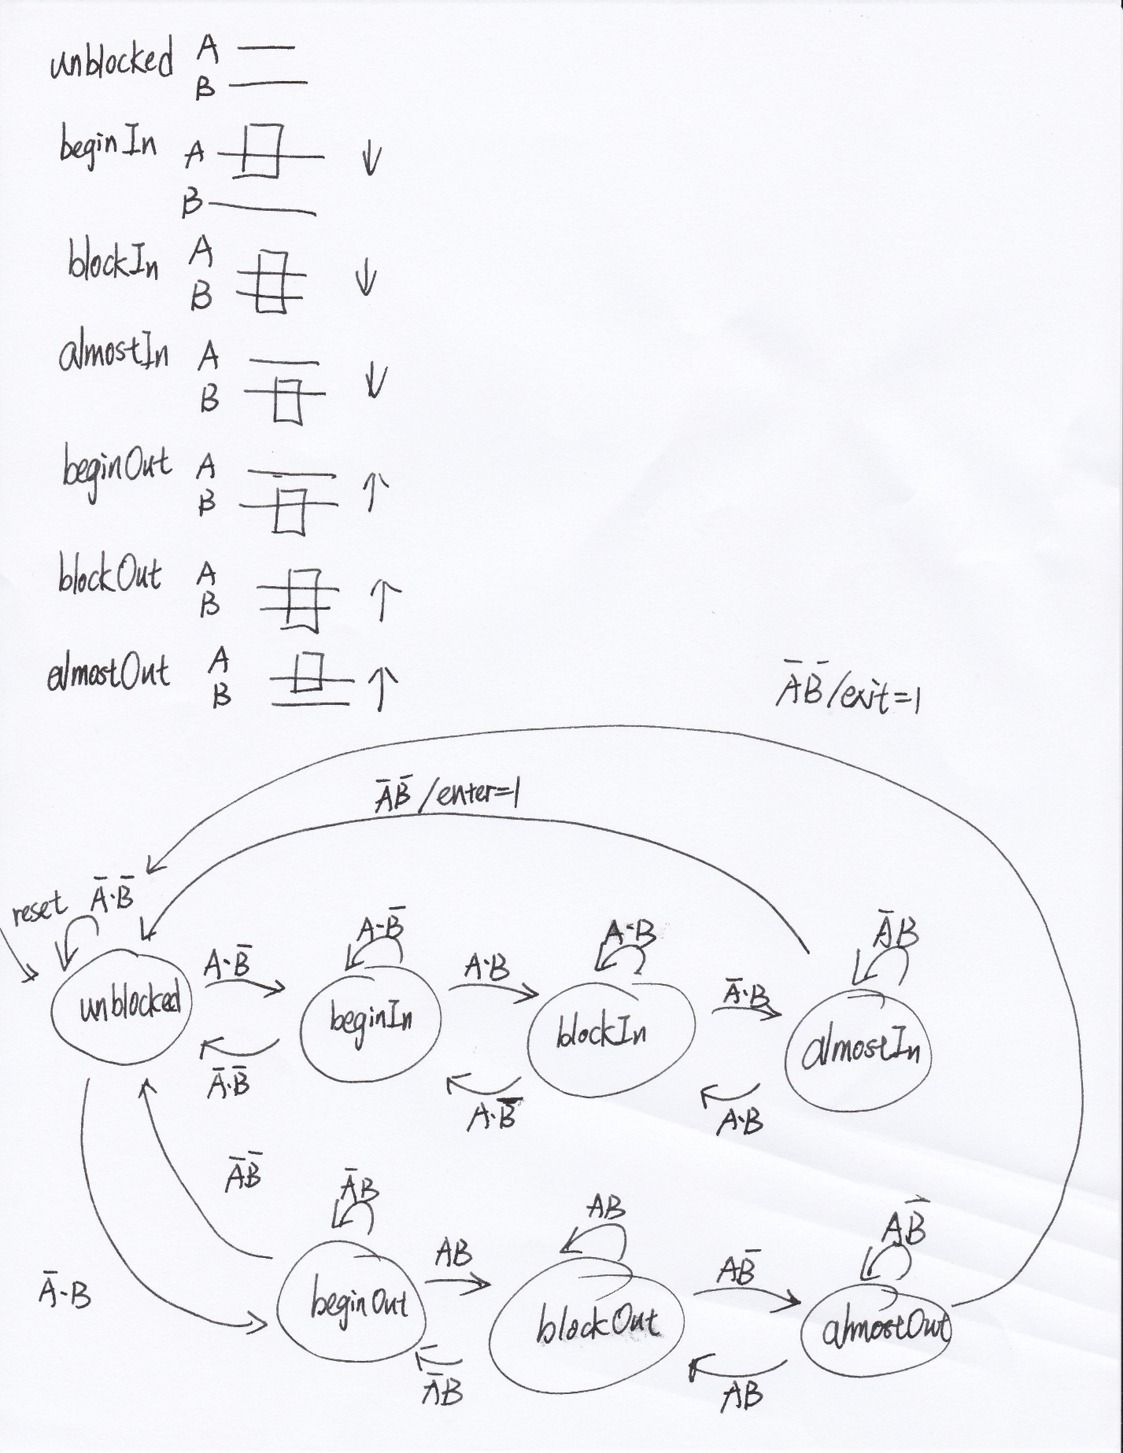

Upon reading the lab assignment, I first designed how many states there should be. There are two sensor in the system. I assume that when car enters, it will trigger sensorA first, then both sensorA and B, then only sensorB, then none of them. So the sequence for a car entering without changing direction is 00,10,11,01,00. Similarly, the sequence for car exiting without changing direction is 00,01,11,10,00.

The reason I designed “in” and “out” in the system is that I want to tackle the changing direction issue. For example, there are two cases where only sensor A is triggered: a car just start to come in, or a car almost leave. It would be impossible for the system to decide which situation this is without adding the “in” and “out” cases. In that case, when the car comes in and then backs up after triggering sensor A, the system will recognize this and not marking it as an exit.

The rest of the system has 5 modules, userInput reduce the possibility the metastability, hexDisplay will display numbers and letters as the assignment states. The counter counts how many cars have entered or left. The parkingLotSensor is the most important part as it tells the rest of the module if there is an enter or exit signal.

## Section 2 Results:

I did not design simulation for userInput as it is unnecessary.

For counter module I simulate enter signal for 30 times and then exit counter for 30 time. Since the parking lot only has a capacity of 25, the counter should stay at 25 and then drop to 25 and stay there.



The counter keeps adding up until it reached 11001(25 in decimal)

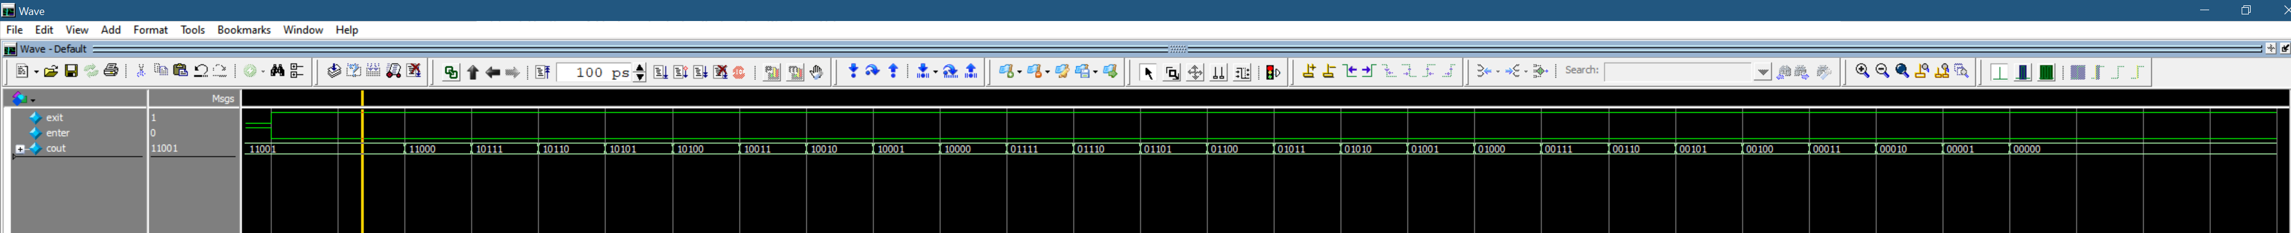

The counter decreases until reaches 0.

For hexDisplay I simulate the counter to be at 0,10,20 and 25 respectively. And the waveform shows that the HEX displays the right number

For the parkingLotSensor I designed the simulator which the car will change direction multiple times and eventually enter or exit the parking lot. So, there should only be one enter and exit signal. The waveform shows the same result.

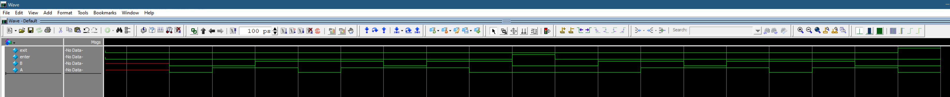

We can see the enter signal at 900ps and exit signal at 1900ps

For the top-level module, I simulate 4 cars enters then 3 cars exit. After that I reset the system and give one exit signal, this shouldn’t happen in real life, but the system should know how to handle it. The counter will stay at zero and the hex display should display “clear0”

Overall, the system satisfies every requirement in the lab assignment. The system can handle the car changing direction issue. The system can display both numbers and letters. The counter has upper and lower limit for parking lot capacity.

## Section 3: Appendix

